Name: **Patrick Rhy A. Andal**Section: **BSCPE 2A**

**Jaguar and Panther Performance Statistical Analysis**

**Abstract**

This study evaluates the performance consistency of two critical systems, Jaguar and Panther, through descriptive statistical analysis. Metrics such as mean, median, mode, range, variance, standard deviation, and coefficient of variation are computed to provide a comprehensive understanding of the systems' operational behavior. Visualizations, including boxplots and histograms, are employed to present the data effectively and highlight key patterns. Findings indicate that while Panther demonstrates more consistent performance with lower variability, Jaguar exhibits significant variability and outliers, which could impact production efficiency. The study concludes with recommendations for addressing these discrepancies to enhance overall operational reliability.

**Introduction**

The Jaguar and Panther systems are central to the production process, particularly in the manufacture of 1K ohm resistors. Ensuring their consistent performance is critical, as fluctuations can lead to inefficiencies, increased costs, and compromised product quality. Feedback from recent operations has highlighted inconsistencies in the performance of these systems, necessitating a thorough investigation.

Descriptive statistical analysis serves as a powerful tool to summarize and interpret performance data, providing insights into central tendencies, variability, and potential anomalies. By focusing on essential metrics such as mean, median, mode, range, variance, standard deviation, and coefficient of variation, this study aims to quantify the performance characteristics of the Jaguar and Panther systems. Additionally, visualizations are employed to enhance interpretability and facilitate informed decision-making.

The primary objective of this analysis is to identify patterns, assess consistency, and recommend actionable strategies to address variability and improve the systems' reliability. By doing so, this study seeks to support operational excellence and maintain high production standards.

**Methodology**

**Data Collection**

The dataset contains performance data for 30 lots, with measurements taken for both Jaguar and Panther systems. Each entry includes:

* Lot number
* Performance metric for the Jaguar system
* Performance metric for the Panther system

**Statistical Metrics**

The following descriptive statistics were calculated for both systems:

* **Mean**: Average performance value.
* **Median**: Midpoint of the data distribution.
* **Mode**: Most frequently occurring value.
* **Range**: Difference between the highest and lowest values.
* **Variance**: Measure of data spread.
* **Standard Deviation**: Square root of the variance.
* **Coefficient of Variation (CV)**: Standard deviation expressed as a percentage of the mean, indicating relative variability.

**Visualizations**

* **Boxplots**: Illustrate data spread, interquartile range, and outliers.
* **Histograms**: Show the frequency distribution of the performance metrics.
* **Bar Charts**: Compare performance across lots for both systems.

**Results**

|  |  |  |
| --- | --- | --- |
| **Metric** | **Jaguar** | **Panther** |
| **Mean** | 1087.8 | 1005.33 |
| **Median** | 998 | 994.5 |
| **Mode** | None (0) | None (0) |
| **Range** | 1050 | 1120 |
| **Variance** | 80749.82 | 27642.85 |
| **Standard Deviation** | 284.20 | 166.30 |
| **CV** | 0.26 | 0.17 |

Table 1. shows the data collected from calculating for the statistical metrics.

**Key Observations**

The analysis of the Jaguar and Panther systems revealed notable differences in their performance characteristics. The Jaguar system exhibited a high degree of variability, as reflected by its coefficient of variation (CV) of 0.26 and a significant range of 1050. These metrics, coupled with the presence of outliers in the upper performance spectrum, suggest inconsistent operation and potential anomalies that warrant further investigation. On the other hand, the Panther system demonstrated a more consistent performance, with a lower CV of 16.54% and a smaller variance and standard deviation compared to Jaguar. However, the Panther system showed a slightly wider range of 1120, indicating occasional deviations from the mean. These findings highlight the need for targeted strategies to improve the reliability and consistency of the Jaguar system while maintaining the stable performance observed in the Panther system. - More consistent performance with a CV of 0.17.

**Discussion**

The performance analysis of the Jaguar and Panther systems reveals crucial insights into their operational characteristics. The Panther system’s low coefficient of variation (0.17) and tightly clustered data distribution indicate a high level of operational consistency and reliability. This stability ensures predictable outputs, which is critical for maintaining production efficiency and meeting quality standards. The histogram and boxplot visualizations further confirm Panther’s concentrated performance metrics, with minimal outliers and limited deviations from the mean.

Conversely, the Jaguar system demonstrates significant performance variability, as evidenced by its higher coefficient of variation (0.26), larger standard deviation, and the presence of extreme outliers. This inconsistency could stem from factors such as irregular maintenance schedules, variations in input materials, or calibration issues. These challenges can disrupt production processes, leading to inefficiencies and potential cost overruns. The wider range of 1050, compared to Panther’s 1120, also suggests sporadic deviations that may need a focused investigation to identify and address root causes.

The differences in variability between the systems emphasize the importance of targeted interventions to enhance Jaguar’s performance consistency. While the Panther system is already operating at a high level, continuous monitoring is necessary to sustain its reliability. For the Jaguar system, a comprehensive review of operational protocols—such as regular calibration, consistent input material quality, and adherence to maintenance schedules—should be prioritized. Additionally, employing advanced analytics to monitor real-time performance metrics could proactively identify anomalies and prevent significant disruptions.

This discussion highlights not only the current state of system performance but also underscores the necessity for proactive maintenance and monitoring strategies to improve reliability and ensure sustained operational excellence in both systems.

**Conclusion**

This analysis provides a comprehensive statistical evaluation of the performance metrics for Jaguar and Panther systems. The Panther system demonstrates superior operational consistency with lower variability, as indicated by its coefficient of variation, variance, and standard deviation. These results confirm its reliability and suitability for maintaining production efficiency. In contrast, the Jaguar system exhibits significant variability and outliers, signaling potential issues in maintenance, calibration, or material input processes that need to be addressed.

The study underscores the importance of targeted interventions to improve Jaguar’s performance consistency. Recommendations include implementing a robust maintenance schedule, standardizing input materials, and employing advanced monitoring systems to identify and rectify anomalies proactively. For the Panther system, maintaining the current operational protocols and conducting periodic reviews will help sustain its high level of performance.

Overall, this analysis emphasizes the critical role of continuous performance monitoring and statistical evaluations in optimizing system reliability and ensuring long-term operational excellence. By addressing identified discrepancies and building on current strengths, both systems can contribute effectively to achieving production goals and maintaining high-quality outputs.

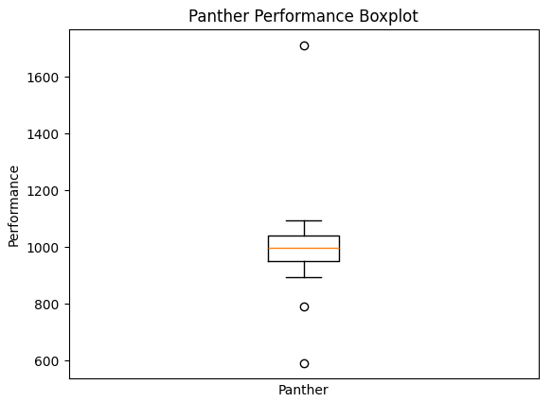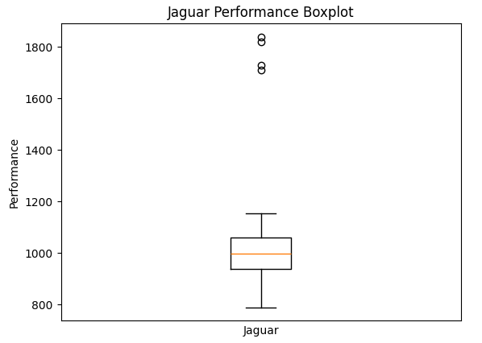**Appendices**

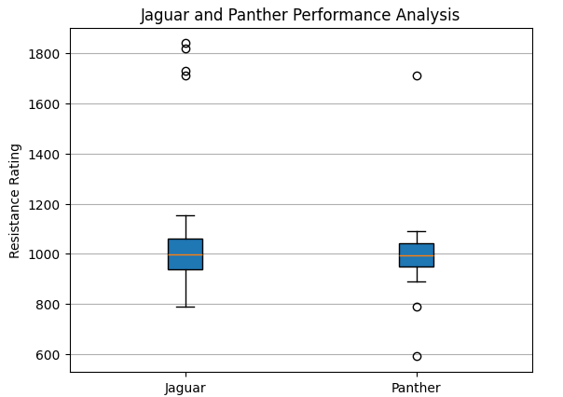

**Appendix B:** Manual Calculations for the Statistical Metrics



